Notes for Thesis

Globally, 34.0 millions are living with HIV virus. 2.5 millions people were newly infected in 2011 alone. 1.7 millions people died with HIV related infection. 14.8 millions are in need of HIV treatment but only 8.0 million people, from low and middle-income countries, on ART therapy – half of them already in need. UNAIDS 2011

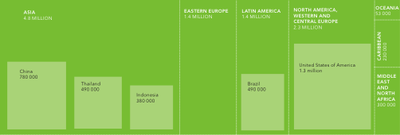

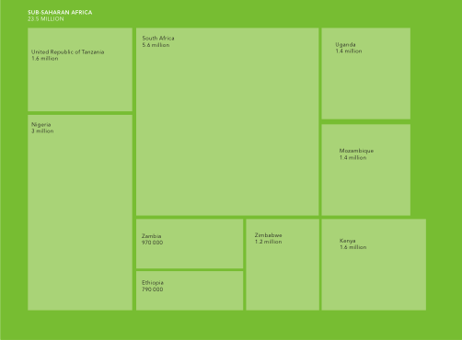

# Sub-Saharan Africa is the most hiv prevalence region with 90% of world HIV positive patients.

# The evolution of this resistance was found to be cumulative, indicating the need for suppressing this ongoing viral replication process. These observations strongly suggest that therapy should be initiated with the most efficacious regimen available, both to suppress viral spread and to inhibit the replication that is required for the evolution of resistance. Article: Genetic correlates of in vivo viral resistance to indinavir, a human immunodeficiency virus type 1 protease inhibitor. Condra el.al

Resistance to the HIV-1 protease inhibitor indinavir involves the accumulation of multiple amino acid substitutions in the viral protease. A minimum of 11 amino acid positions have been identified as potential contributors to phenotypic resistance. Three or more amino acid substitutions in the protease are required before resistance becomes measurable (≥four-fold). Further losses in susceptibility follow the stepwise accumulation of additional amino acid substitutions, indicating that antiviral activity (selective pressure) is maintained despite the appearance of multiple amino acid substitutions in the viral protease. Importantly, the sequential nature of these changes indicates that the effects of these substitutions are additive, and that the evolution of resistance is driven by viral replication. This result has significant implications for therapy. It predicts that viral variants resistant to indinavir are unlikely to pre-exist in protease inhibitor-naive patients, and further, that high-level resistance can only develop if the virus is allowed to replicate in the presence of the drug. The use of indinavir in combination with other antiretroviral agents has been demonstrated to dramatically reduce the incidence of resistance mutations, suggesting that with maximal suppression of viral replication, long-term control of HIV-1 infection may be achievable. Thus, the goal of therapy must be to never to allow the virus to replicate. This can be best accomplished by initiating therapy with a maximally suppressive regimen, to reduce viral replication as much as possible, and by imposing a high genetic barrier to resistance. Previous use of other protease inhibitors or inadequate adherence to therapy may compromise the long-term benefit of indinavir by allowing the virus to gain a foothold through the development of resistance. An understanding of these issues will be critical in realizing the full potential of this potent new drug for the control of HIV-1 infection. Article: Resistance to HIV protease inhibitors. C. A. Lee,C. M. Kessler

In sub-Saharan Africa, a record 2.3 million people were added to treatment programmes in the last two years—an increase of 59%. South Africa scaled up its treatment services to reach 1.7 million people—an increase of 75% in the last two years.

In 2011, this decline continued, with evidence showing that the drop in the number of people dying from AIDS-related causes is accelerating in several countries.

Investment for HIV treatment - US$ 8.6 billion in 2011. South Africa is the country that has made the highest domestic investment in AIDS among all low- and middle-income countries. It alone invested US$ 1.9 billion last year from public sources, resulting in a five-fold increase between 2006 and 2011. By 2015, the total investment required for zero new HIV infection is US $ 24 billion but the current investment is US $16.8 billion.

Evolution of HIV and HIV subtypes

One of the CRFs is called A/E because it is thought to have resulted from hybridization between subtype A and some other "parent" subtype E. However, no one has ever found a pure form of subtype E. Confusingly, many people still refer to the CRF A/E as "subtype E" (in fact it is most correctly called CRF01\_AE. REF: Los Alamos National Laboratory (2005-2006) '[The Circulating Recombinant Forms (CRFs)](http://www.hiv.lanl.gov/content/sequence/HIV/CRFs/CRFs.html" \t "_blank)

A virus isolated in Cyprus was originally placed in a new subtype I, before being reclassified as a recombinant form A/G/I. It is now thought that this virus represents an even more complex CRF comprised of subtypes A, G, H, K and unclassified regions. The designation "I" is no longer used.

Ref : Gao F et. al (1998, December) '[An Isolate of Human Immunodeficiency Virus Type 1 Originally Classified as Subtype I Represents a Complex Mosaic Comprising Three Different Group M Subtypes (A, G, and I)](http://www.ncbi.nlm.nih.gov/pubmed/9811767" \t "_blank)' Journal of Virology 72(12)

Subtype A and CRF A/G predominate in West and Central Africa, with subtype A possibly also causing much of the Russian epidemic. Ref: Bobkov AF et. al (2004, October) '[Temporal trends in the HIV-1 epidemic in Russia: predominance of subtype A](http://www.ncbi.nlm.nih.gov/pubmed/15332265" \t "_blank)' J Med Virol 74(2)

Historically, subtype B has been the most common subtype/CRF in Europe, the Americas, Japan and Australia and is the predominant sub-type found among MSM infected in Europe. Ref: Le Vu S, et. al (2010, 9th September) '[Population-based HIV-1 incidence in France, 2003–08: a modelling analysis](http://www.ncbi.nlm.nih.gov/pubmed/20832367" \t "_blank)' The Lancet 10

· Subtype C is predominant in Southern and East Africa, India and Nepal. It has caused the world's worst HIV epidemics and is responsible for around half of all infections.

· Subtype D is generally limited to East and Central Africa. CRF A/E is prevalent in South-East Asia, but originated in Central Africa. Subtype F has been found in Central Africa, South America and Eastern Europe. Subtype G and CRF A/G have been observed in West and East Africa and Central Europe.

· Subtype H has only been found in Central Africa; J only in Central America; and K only in the Democratic Republic of Congo and Cameroon. NO REF

The period from infection to AIDS or death is shorter if the infecting virus is CRF. L ' 13th Conference on Retroviruses and Opportunistic Infection

Ref: Baeten D et. al (2007, 15th April) '[HIV-1 subtype D infection is associated with faster disease progression than subtype A, in spite of similar HIV-1 plasma viral loads](http://www.ncbi.nlm.nih.gov/pubmed/17357054" \t "_blank)' Journal of Infectious Disease 195(8)

Ref: Kanki PJ et. al (1999, January) '[Human Immunodeficiency Virus Type 1 Subtypes Differ in Disease Progression](http://www.ncbi.nlm.nih.gov/pubmed/9841824" \t "_blank)' Journal of Infectious Diseases, 179(1)

Ref: Nelson KE et. al (2007, November) '[Survival of blood donors and their spouses with HIV-1 subtype E (CRF01 A\_E) infection in northern Thailand, 1992-2007](http://www.ncbi.nlm.nih.gov/pubmed/18032938" \t "_blank)' AIDS 21(S6)

It has been observed that certain subtypes/CRFs are predominantly associated with specific modes of transmission.[16](http://www.avert.org/hiv-types.htm#ref15) In particular, subtype B is spread mostly by homosexual contact and intravenous drug use (essentially via blood), while subtype C and CRF A/E tend to fuel heterosexual epidemics (via a mucosal route). Ref: Taylor BS et. al (2008) '[The Challenge of HIV-1 Subtype Diversity](http://www.ncbi.nlm.nih.gov/pubmed/18971501" \t "_blank)'

In 1981, the first patient of HIV AIDS was identified in the USA. Probing of the causative agent of the disease – the HIV -1 implied that it is a retrovirus that again fall under lentivirus. Exploration of the retrovirus led researchers to find similar type of retrovirus in non-human primates that were then called as Simian Immunodeficiency Virus (SIV). Research has established that HIV in human was a result of zoonotic transmission of SIV from non-human African wild primates (Bailes et al. 2002). About 40 different primates, in Africa, are infected with SIV and some are harboring some than one strain of SIVs. Phylogenetic analysis of SIVs from African non-human primates and two HIVs (HIV -1 and HIV -2) in human provided remarkable understanding of viral transmission and evolution from non-human primates to human.

It is now clear that HIV-1 and HIV-2 transmission to human are independent and their source are different. Discovered in 1986 AD, HIV-2 is transmitted from Sooty mangabey monkeys (Cercocebus atys) and the HIV-2 prevalence is also high in the geographical location of these monkeys in West Africa (Santiago et al., 2005). Sooty mangabey monkeys are naturally infected by a strain of SIV that is very close to HIV-2 (Hirsch et al. 1989) and the phylogenetic analysis of all HIV-2 strains show that it closely groups with the SIVsmm strains (Geo et al 1992). SIVsmm does no harm to its host monkeys and must have modified to produce multiple strain and subsequently multiple zoonotic transmissions from sooty mangabey monkeys to human (Hahn et al 2000). Although HIV-2 subtypes A to G are identified in human, it is assumed that more subtypes are introduced into human (Gurtler 2004) but are lost for low adaptation fitness (Damond et.al 2004).

Initial researches show that chimpanzees (Pan troglodytes) are the source of HIV-1 infection to human (Peeters et al. 1989; Huet et al. 1990) but the lack of enough evidence from vast number of other chimpanzees being test showed negative results and then subsequently discarded the idea (Vanden Haesevelde et al. 1996). Years later, in 1999, another chimpanzee was tested positive for SIV close to HIV-1. Analysis of chimpanzee subspecies started with mitochondrial DNA (mtDNA) analysis (Groves 2001) that recorded four: western (Pan troglodytes verus), Nigerian (Pan t. ellioti), central (P. t. troglodytes) and eastern (Pan t. schweinfurthii) chimpanzees (Gagneux et al. 1999). Retrospective research showed that all chimpanzee tested negative were subspecies *P.t versus* (Prince et al. 2002; Switzer et al. 2005) and those tested positive were *P.t troglodytes or P.t. schweinfurthii* (Geo et.al 1999, Corbet et al 2000, Santiago et al. 2003; Worobey et al. 2004; Keele et al. 2006, 2009; Van Heuverswyn et al. 2007). These studies and evidence from faecal samples (Keele et al 2006) confirmed the source of HIV-1 as *Pan troglodytes*.

HIV-1 genome analysis shows three groups: M (for ‘main’), N and O.

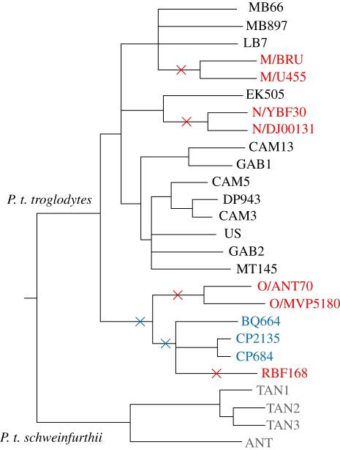

Origins of HIV-1. The phylogenetic relationships among strains of SIVcpz (black from P. t. troglodytes, grey from P. t. schweinfurthii), SIVgor (blue) and HIV-1 (red). The red crosses mark four branches on which cross-species jumps to humans occurred; the two blue crosses indicate alternative possible branches on which a chimpanzee-to-gorilla transmission occurred. The HIV-1 strains fall into three groups (M, N and O; only two representatives of each group are shown), and a recently described fourth lineage (RBF168). Adapted from trees shown in [Takehisa et al. (2009)](http://www.ncbi.nlm.nih.gov/pmc/articles/PMC2935100/" \l "RSTB20100031C48" \t "mainwindow) and [Plantier et al. (2009)](http://www.ncbi.nlm.nih.gov/pmc/articles/PMC2935100/" \l "RSTB20100031C35" \t "mainwindow) and Paul et al (2010). [It has copy right. Need permission]

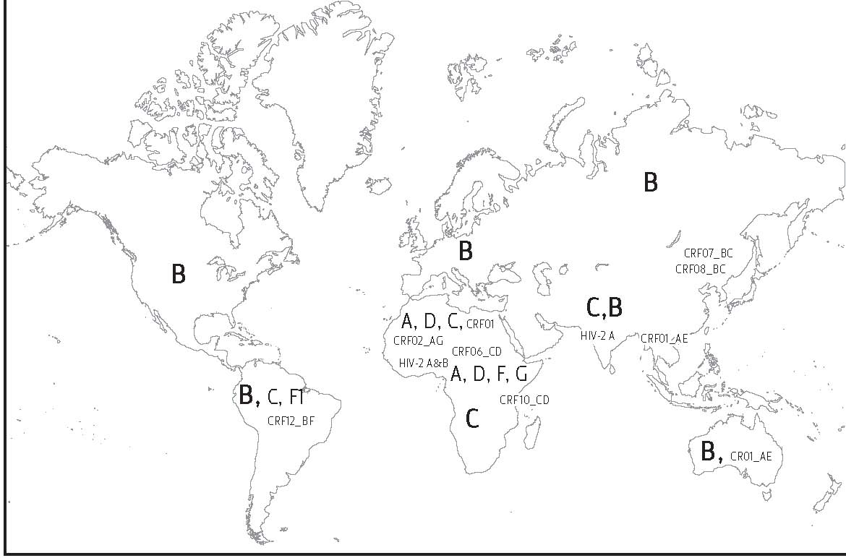

<http://ftguonline.org/files/images/FTGU_2_1_01_img_1.jpg>

HIV types, Subtypes, Subsubtypes and Circulating Recombinant Forms

HIV is hugely diverse virus. Its diversity is obtained from phylogenetic analysis of genomic region to genome wide sequence. It creates its diversity to adapt in different environment like host immune system and drug pressure.

Classification of HIV by group, subtype and subsubtype require a reference sequence with the criteria: a sequenced full-length genome, no recombination history, HIV genome sequence published in peer reviewed citation, isolated from recent samples, HIV is covered in major geographical distribution, HIV has no sign of hypermutation, HIV genome sequence is real sequence from a patient, HIV genome has no extreme indels, and the virus must be viable and intact (Leitner et al 2005).

There are two distinct types of HIV: HIV-1 and HIV-2. These viruses can be differentiated by their genome organization and phylogenetic relationship (Hahn et al 2000), pathogenesis, transmissibility and pattern of spread (De cock et al 1993, Kanki and De cock, 1994). A notable difference is the source of the infection to human. Evidences show that HIV-1 is zoonotic transmission to human from chimpanzee *(Pan troglodytes*) and HIV-2 from sooty mangabey (*Cercocebus atys*). The genome wide sequence of both HIV show that HIV-2 has an extra gene “vpx” which is lacking in HIV-1 genome (Henderson et al 1988, Kappes et al 1988, Tristem et al 1992, Bergamaschi et al 2009). Drug resistance clinical results show that non-nucleoside reverse transcriptase inhibitors (NNRTIs) anti-retroviral drugs are effective against HIV-1, but non-effective against HIV-2 reverse transcriptase (Hizi et al 1993).

Isolation, characterization and sequence analysis of each type of HIV show that there exist genomic heterogeneity and variability among different isolates (Benn et al 1985, Hahn et al 1985, Wong-Stall et al 1985). Analysis of isolates within a patient and between patients demonstrates that intra-patient isolates are more related than inter-patient isolates (Hahn et al 1986). HIV-1 isolates from around the world and their phylogenetic sequence analysis reveals distinct subtypes that cluster together to form three groups: M (Main), O (Outlier) and N (non-M and non-O) (Robertson et al 2000, Leitner et al 2005), which represent three independent zoonotic transfection of SIV from chimpanzee to human (Hahn et al 2000, Sharp et al 2001).

Within each group, phylogeny of the genomic region with most variability allows classification of the virus to subtypes. An unrooted phylogenetic analysis of the HIV-1 isolates from group M using complete gag, pol, env and nef sequences or full length genome sequence analysis show distinct subtypes A – D, F – K (figure Buonaguro et al 2007). The phylogenetic clades of subtypes can be constructed from any part of the HIV-1 genome when the alignment is at least 300-500 bases long (Leitner et al 2005). Sequence length shorter than threshold from genomic regions under higher evolutionary pressure e.g. env V3 can reconstruct the phylogenetic clades distinguishing the subtypes, while regions under slower evolutionary change need long sequences to give reliable results (Leitner et al 2005). Further phylogenetic structure for subtype A and F have been identified leading to the classification of subsubtypes A1 and A2 for subtype A and F1 and F2 for subtype F (Gao et al 2001, Lietner et al 2005).

Two or more HIV subtypes infecting a single patient create inter-subtype recombinant forms called “unique recombinant forms” (McCutchan 2006). Isolation and identification of unique recombinant form from at least three epidemiologically unlinked patients and characterized by full-length genome sequencing is designed as circulating recombinant forms (CRFs) (Los Alamos Laboratory [[http://www.hiv.lanl.gov/content/hiv-db/CRFs/CRFs.html](http://www.hiv.lanl.gov/content/hiv-db/CRFs/CRFs.html" \t "_blank)]). There are huge numbers of CRFs known; the most prevalent are CRF01\_AG, CRF02\_AG in West Africa and CRF01\_AE in Southeast Asia. Country specific prevalent CRF may be different e.g. CRF01\_AG in Nepal and India (Shahid et al 2011). All discovered CRFs are documented in [http://www.hiv.lanl.gov/content/hiv-db/CRFs/CRFs.html](http://www.hiv.lanl.gov/content/hiv-db/CRFs/CRFs.html" \t "_blank).

Unlike group M, group O is endemic and largely confined to certain geographical region of Cameroon and neighboring West Central African region; group O only represents a small minority of HIV-1 strain in the region (Peeters et al 1997, Jaffe and Schochetman 1998, Janssens et al 1999). Group N is also confined to Cameroon and is found in limited isolates only (Simon et al 1998).

HIV-2, first isolated from patients in West Africa, exhibits HIV-1 AIDS like symptoms but shows seronegative to HIV-1 assay (Clavel et al 1986, Clavel et al 1987, Leys et al 1990, Gao et al 1992). Both viruses exhibit significant similarity at genome level (guyader et al 1987).

HIV-2 is classified to epidemic subtypes (A, B) and non-epidemic subtypes (C, D, E, F) [Hahn et al 2000, Tebit et al 2007]. Researchers expect that HIV-2 subtypes are independent cross-species transmissions of SIV to human population, very much like HIV-1 groups [Hahn et al]. Aguchi et al [2000] suggested a new HIV-2 subtype G. Some researches are done on subtypes A and B (Gao et al 1994, Chen et al 1997, Damond et al 2001, Damond et al 2002, Pieniazek et al 2004, Tebit et al 2007) and very little is known about the other subtypes.

Phylogenetic analysis of HIV and their SIV relatives from the primates that are the sources of zoonotic infection to human, show that HIV can be distinctly grouped into two type: HIV1 and HIV2 (figure: Phylogenetic of lentivirus). Both types of HIV are highly related retroviruses from lentivruses *genus*. The phylogenetic analysis is done from whole genome data or Env region [Hahn et al 1985, Starcich et al 1986], which is genetically highly constrained as it gets exposed on HIV surface. The phylogenetic analysis also shows that HIV1 and HIV2 get clustered with the SIV from their source.

Phylogenetic analysis of HIV-1 shows that it groups into three distinct clades. HIV -1 is further classified to groups: M (Main), O (Outlier) and N (non-M/non-O). Group M is the most widely spread HIV-1. It has infected millions of people throughout the world. It has spread to more or less in every country of the world [ref]. HIV-1 subtypes O and N are geographically limited to West-central Africa. SIV continuously undergo genetic variation in the reservoir and at different time points, SIVs are transmitted to human independently. This give rise to HIV-1 subtypes M, N and O.

Phylogenetic analysis of HIV-1 subtype M using gag, pol and env sequences shows that high genetic variation

Gag, env and pol region in HIV-1 subtype M show high genetic variation. The phylogenetic analysis with sequences from these region shows distinct clades. This further, classifies subtype M into 8 subsubtypes:

HIV is classified into two types: HIV-1 and HIV-2. HIV-1 and HIV-2 can be distinguished from each other from evidence of zoonotic transmission of primate lentivirus from difference source.

Full-length genomes of both types of show that HIV-2 has extra viral protein X (vpx) gene. The source of HIV-1 infection to human is

This classification is based on pyhologenetic analysis using their genomic sequences with significant variation between them (fig).

### [Low peripheral blood viral HIV-2 RNA in individuals with high CD4 percentage differentiates HIV-2 from HIV-1 infection.](http://europepmc.org/abstract/MED/10195267)

### [Field evaluation of alternative testing strategies for diagnosis and differentiation of HIV-1 and HIV-2 infections in an HIV-1 and HIV-2-prevalent area](http://journals.lww.com/aidsonline/Abstract/1997/15000/Field_evaluation_of_alternative_testing_strategies.5.aspx)

Phenotypically, HIV-2 disease progression is much slower than HIV-1 [Popper et al 1999] and currently developed NNRTI drugs are ineffective against HIV-2 [Hizi et al 1993].

HIV-2 diverse groups using the analysis of POL, ENV and long terminal repeat regions [Gao et al 1992]. HIV-2, SIVsm and SIVmac are highly diverse group of lentiviruses which cannot be separated into distinct phylogenetic lineages according to species of origin.

HIV-1 subtyping using phylogenetic analysis of the reverse transcriptase and protease complete HIV-1 genome sequences [Gonzales et al 2001].

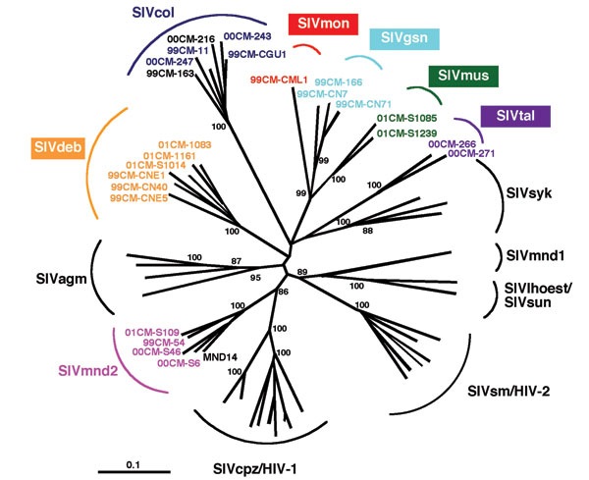

<http://wwwnc.cdc.gov/eid/images/01-0522-F2.jpg>

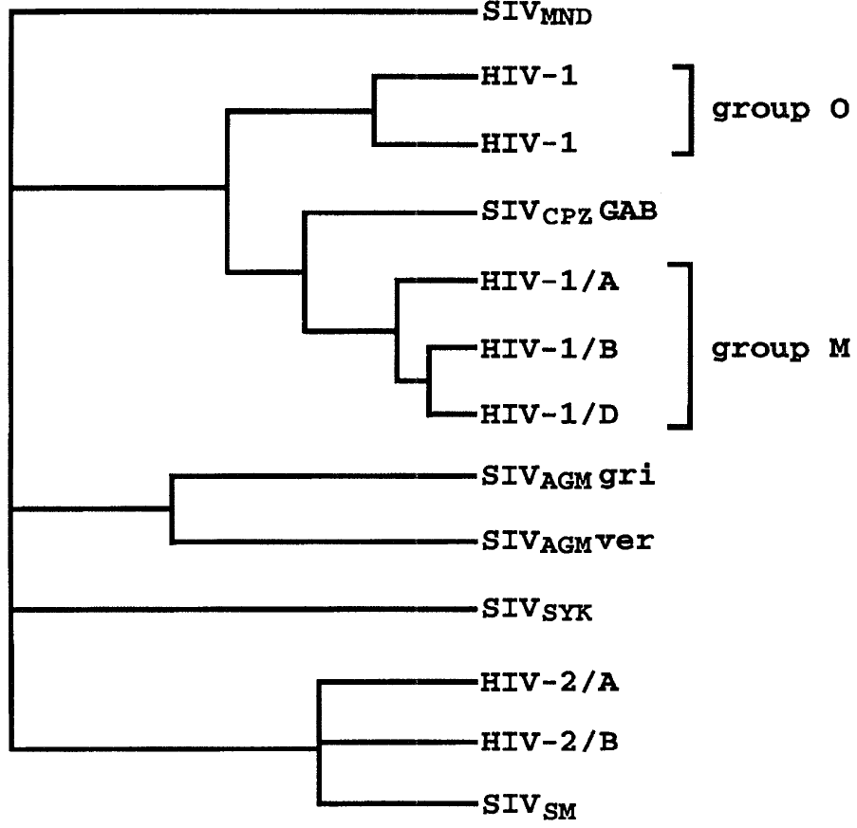

source article: sharp et al 1995. Cross-species transmission and recombination of AIDS Viruses

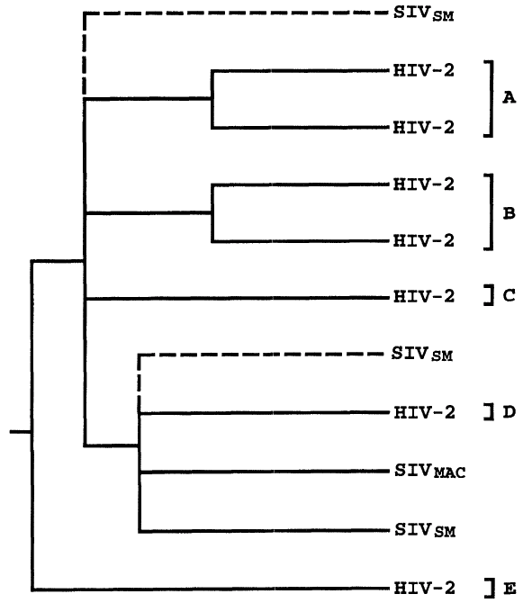

source: Adapted from Gao et al 1994. Article: Genetic diversity of HIV type 2

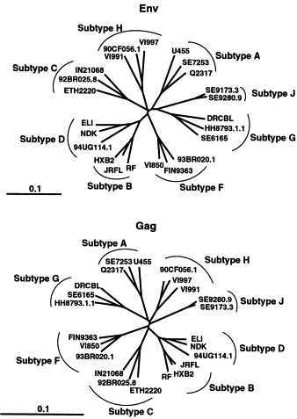

# source: McGrath et al 2001. Article: Using HIV-1 sequence variability to explore virus biology

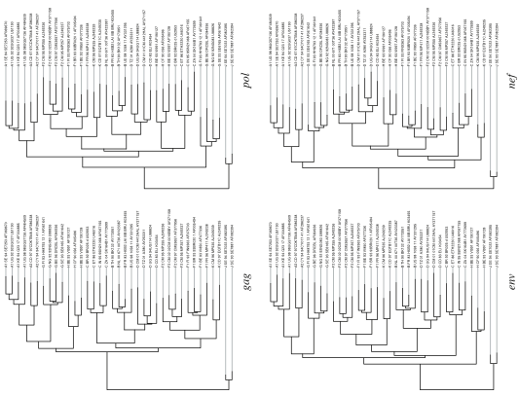

Source: Leitner et al 2005. Article: HIV-1 subtype and sicrulating recombinant form

HIV-1 Group M sequences showing distinct subtypes.

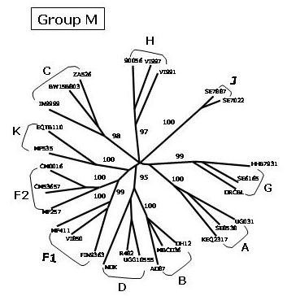

source: Buonaguro et al retrovirology 2007

Evolutionary relationships among non-recombinant HIV-1 strains

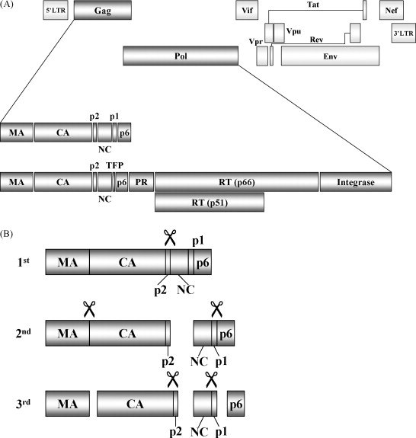

source: <http://ars.els-cdn.com/content/image/1-s2.0-S0166354209004902-gr1.jpg>

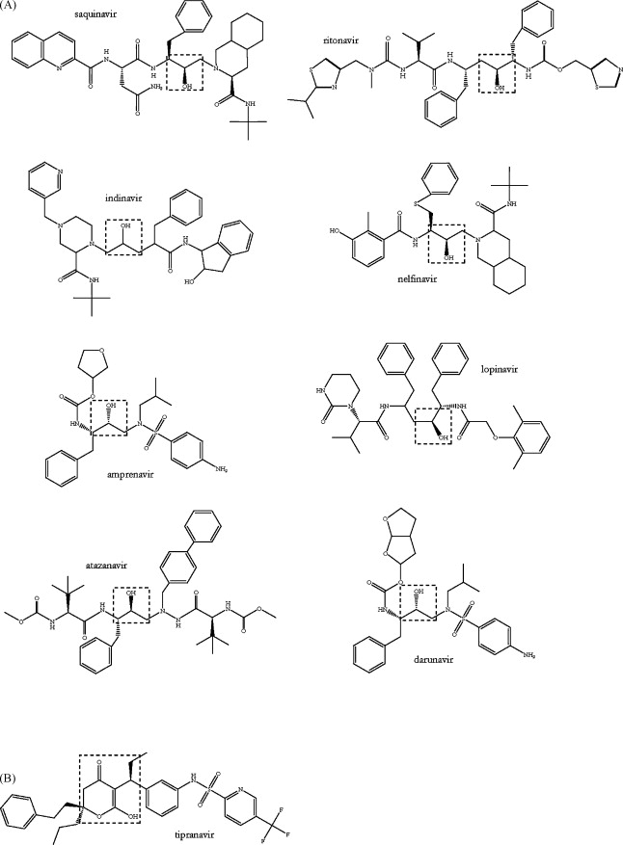

Nine protease inhibitors

Source: <http://ars.els-cdn.com/content/image/1-s2.0-S0166354209004902-gr3.jpg>

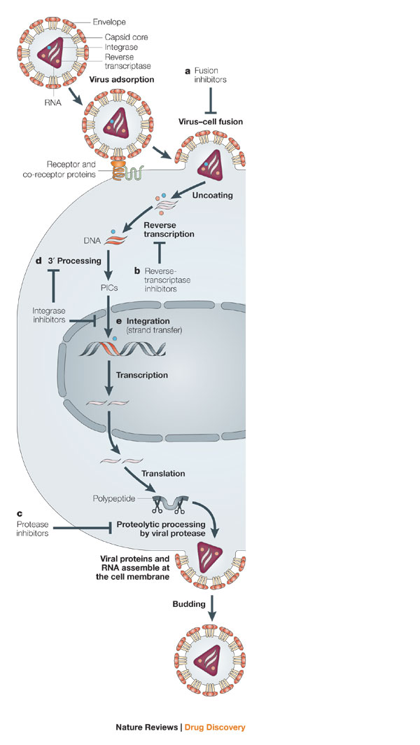

source: <http://www.nature.com.libgate.library.nuigalway.ie/nrd/journal/v4/n3/images/nrd1660-f1.jpg>

article: [Integrase inhibitors to treat HIV/Aids](http://www.nature.com.libgate.library.nuigalway.ie/nrd/journal/v4/n3/full/nrd1660.html)

Yves Pommier, Allison A. Johnson & Christophe Marchand

Nature Reviews Drug Discovery 4, 236-248 (March 2005)

Current therapies target attachment/fusion of HIV to the host cell outer membrane (a) and the viral enzymes reverse transcriptase (b) and protease (c). Integrase, the third viral enzyme, catalyses two steps in the viral replication cycle. First, integrase catalyses the processing of the 3'-ends of the viral cDNA (3'-processing step) (d); integrase then remains bound in a complex with the viral cDNA ends in the pre-integration complexes (PICs). Following nuclear translocation of the PICs, integrase catalyses the insertion (strand-transfer step) of the viral cDNA ends into host chromosomes (e) ([Fig. 2](http://www.nature.com.libgate.library.nuigalway.ie/nrd/journal/v4/n3/fig_tab/nrd1660_F2.html)). The diketo aryl (DKA) integrase inhibitors preferentially block the strand-transfer step, whereas other inhibitors ([Fig. 4](http://www.nature.com.libgate.library.nuigalway.ie/nrd/journal/v4/n3/fig_tab/nrd1660_F4.html)) block both the 3'-processing and strand-transfer steps.

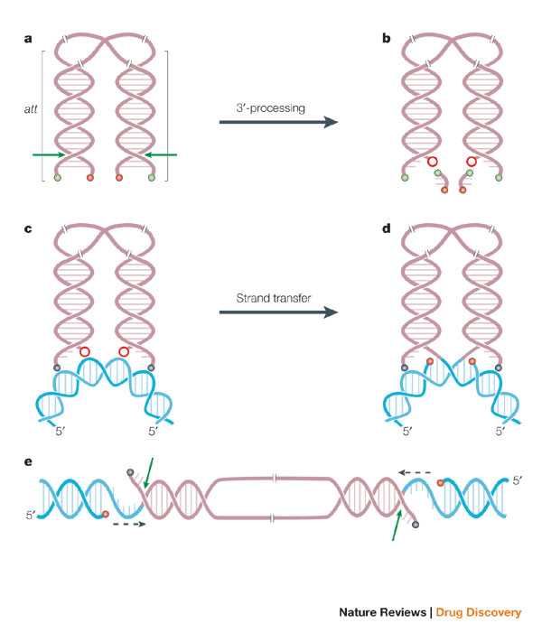

source: <http://www.nature.com.libgate.library.nuigalway.ie/nrd/journal/v4/n3/images/nrd1660-f2.jpg>

article: [Integrase inhibitors to treat HIV/Aids](http://www.nature.com.libgate.library.nuigalway.ie/nrd/journal/v4/n3/full/nrd1660.html)

Yves Pommier, Allison A. Johnson & Christophe Marchand

Nature Reviews Drug Discovery 4, 236-248 (March 2005)

The figure shows the viral DNA recombination (att) sites. 3'-processing takes place in the cytoplasm following reverse transcription ([Fig. 1](http://www.nature.com.libgate.library.nuigalway.ie/nrd/journal/v4/n3/fig_tab/nrd1660_F1.html)). It is a water-mediated endonucleolytic cleavage (green arrow in a and [Box 1](http://www.nature.com.libgate.library.nuigalway.ie/nrd/journal/v4/n3/box/nrd1660_BX1.html), figure part a) of the viral DNA immediately 3' from the conserved CA dinucleotide ([Box 1](http://www.nature.com.libgate.library.nuigalway.ie/nrd/journal/v4/n3/box/nrd1660_BX1.html), figure part a). 3'-processing generates reactive 3'-hydroxyls at both ends of the viral DNA (red circles (b); other 3'-hydroxyl ends and 5'-phosphate ends are shown as red and green dots, respectively). Integrase multimers (not shown) remain bound to the ends of the viral DNA as the pre-integration complexes (PICs) translocate to the nucleus. The second reaction (c to d) catalysed by integrase is strand transfer (3'-end joining), which inserts both viral DNA ends into a host-cell chromosome (acceptor DNA in blue). Strand transfer is coordinated in such a way that each of the two 3'-hydroxyl viral DNA ends (red circles) attacks a DNA phosphodiester bond on each strand of the host DNA acceptor with a five-base-pair stagger across the DNA major groove (d). Strand transfer leaves a five-base, single-stranded gap at each junction between the integrated viral DNA and the host acceptor DNA, and a two-base flap at the 5'-ends of the viral DNA (d and e). Gap filling and release of the unpaired 5'-ends of the viral DNA (arrows in e) are carried out in coordination with cellular repair enzymes.

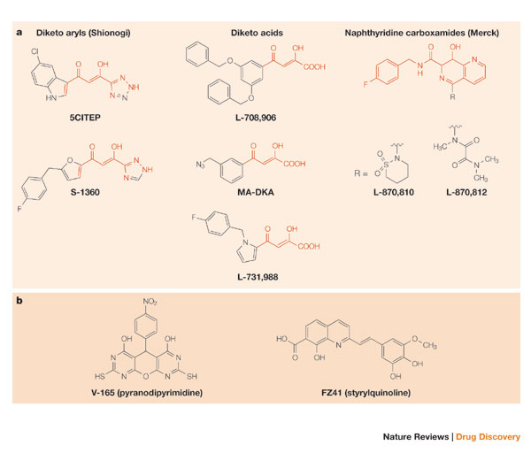

source: <http://www.nature.com.libgate.library.nuigalway.ie/nrd/journal/v4/n3/images/nrd1660-f4.jpg>

article: [Integrase inhibitors to treat HIV/Aids](http://www.nature.com.libgate.library.nuigalway.ie/nrd/journal/v4/n3/full/nrd1660.html)

Yves Pommier, Allison A. Johnson & Christophe Marchand

Nature Reviews Drug Discovery 4, 236-248 (March 2005)